Mobile IP to Simple IP Fallback Mechanism Architecture Analysis

Security Classification: | Internal-Symbian
Status: | Draft
Revision: | 0.3
Last Revised Date: | Feb 26, 2004
Team/Department : | CDMA/Networking
Author(s): | Voicu Tulai, Victor Minkovski
Owner(s): | CMDA TA

Approver(s): | Philippe Gabriel | Distribution: | Philippe Gabriel, Dan Fandrich, Bill Gordon

Table of Contents
1 Introduction 3
2 Analysis 3
3 Options for selecting the Simple IP fallback record in the service view 7
3.1 Using CNifAgentRef 7
3.2 Using NetCon 9
3.3 Using existing Nifman connection fallback mechanism 10
3.4 Combining Mobile IP and Simple IP settings 12
4 Conclusion 13

Table of Figures

Figure 1: Nifman Mobile IP to Simple IP fallback sequence 4
Figure 2: Modified CNifAgentRef state machine 5
Figure 3: Activity times 6
Figure 4: Option 1 activity timing 7
Figure 5: Option 2 activity timing 11

Summary Tables

Table 1: Option 1 summary 8
Table 2: Option 2 summary 9
Table 3: Option 3 summary 11

Introduction

The Mobile IP to Simple IP fallback mechanism allows MS to retry the connection by using Simple IP when a Mobile IP registration attempt fails.

Analysis

When a connection is attempted Netcon is used to select an IAP and the current CommDb views are updated with the service and bearer records corresponding to the selected IAP. An agent is loaded based on the bearer record and a NIF is loaded and initialized based on the service record.

In the fallback scenario the Mobile IP connection identified by the current service record fails and a new Simple IP connection has to be initiated. It is assumed that the Simple IP connection is defined in a separate service record.

Actions to implement the fallback:

- Detect the Mobile IP failure
- Stop the NIF
- Select the new Simple IP service record
- Re-start the NIF

These actions are detailed in the sequence diagram below. Description:

- When the first ESOCK sub-session is started CNifSession::Start is called
- CNetworkControllerBase::SelectAgent is called to select an IAP based on the settings in the ConnectionPreferences table
- An IAP is selected and the CommDB views are updated with the corresponding records in the service and bearer tables
- SelectComplete is called to indicate the end of selection and the CNifAgentRef instance is created and started
- Connect is called to initialize the agent
- ConnectComplete indicates that the agent was initialized successfully
- The PPP NIF is started and it signals the completion of the negotiation phase through LinkLayerUp. Note that PPP is aware not to negotiate an IP address by looking at the current service record, which specifies that MobileIP is used
- When PPP completes the Mobile IP daemon is asked to register through ConfigureNetwork
- The daemon fails and an error is reported back with the KLinkLayerOpen progress notification. Note that the error can be either an operational error from the daemon, a timeout error from CNifAgentRef itself or a “server died” error if the daemon is killed while processing the configuration request
- In order to execute the fallback PPP has to be re-initialized and it should re-negotiate all parameters (LCP, NCP, etc) for a Simple IP connection. The most important differences in between the Mobile IP and the Simple IP negotiations is the addition of the IP address negotiation option for IPCP and the authentication option.
- PPP is stopped and when done (LinkLayerDown) the Simple IP service record is selected in CommDb.
- PPP is re-started and this time will negotiate the Simple IP parameters.
- When PPP finishes a CNifNullConfiguration instance is created (as specified by the current service record) and the ConfigureNetwork call is completed right away with no error

Refer to figures 1 & 2 (below) for the fallback sequence in Nifman, and a state machine required to execute this sequence.
Refer to figure 3 (below) for the approximate fallback activity times.

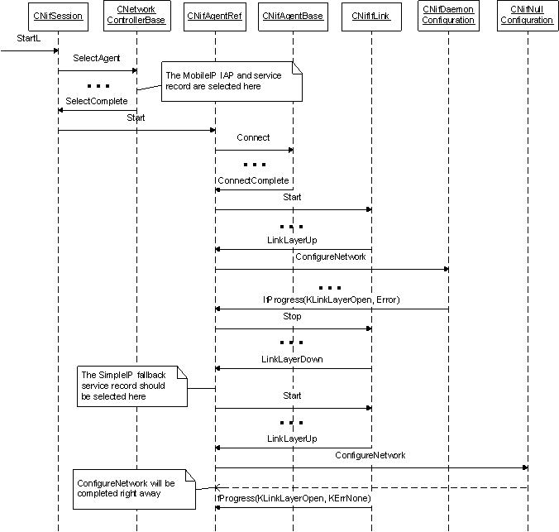
Figure 1: Nifman Mobile IP to Simple IP fallback sequence

New CNifAgentRef states
Existing CAgentRef states
Connecting
Stopping
Started
Disconnecting
Configuring
Link Up
Falling back to Simple IP
Start
Agent Connected /Start NIF
Reconnect Complete
Link Layer Down / Disconnect
Link Layer Down / Reconnect
Link Layer Down/
Reconnect
Link Layer Down / Disconnect
Stop
Stop
Link Layer Up /
ConfigureNetwork
Progress(KLinkLayerOpen, Error) / Stop
Success / Start NIF
Link Layer Down / Disconnect
Failure/ Disconnect
Agent Stopped
Progress(KLinkLayerOpen, KErrNone) /
Start Timer
Timer Complete / Stop Timer
Link Layer Down /
Fall Back
Packet Activity
Reconnecting
Figure 2: Modified CNifAgentRef state machine

Figure 3: Activity times
Activity | Approximate time, seconds
Bring up the air interface t₁ | 3
Establish PPP connection t₂ | 2
Perform Mobile IP registration t₃ | 2
Detect Mobile IP registration attempt failure t₄ | 2
Perform Simple IP negotiation t₅ | Very short
Tear down the PPP connection | Negligible
Tear down the air interface | Negligible

Options for selecting the Simple IP fallback record in the service view

Using CNifAgentRef

The Simple IP fallback record is specified when the Mobile IP record is selected. This can be implemented by adding a field to the service table that would allow a Mobile IP record to be statically linked with the corresponding Simple IP fallback record if the current mode of operation is “fallback” (this is defined using an existing field in DefaultCDMA2000SettingsTable). When the Mobile IP connection fails this field is used to select the new service record without Netcon being involved. This option requires changes to Nifman and CommDb and ensures that the same agent is used for the Simple IP connection. If required, the “link” field can be overridden programmatically so that another Simple IP record is selected at runtime. Refer to figure 2 for required changes to Nifman’s CNifAgentRef.

A drawback of this option is the possibility of Mobile IP negotiation failure due to a failure of the air interface. Under this scenario, Simple IP negotiation is attempted over a non-functioning air interface, resulting in an unnecessary delay.
The fallback timing is illustrated below:
Mobile Station
Base Station
Home Agent
Bring up the air interface
t₁
Establish PPP connection
t₂
Perform Mobile IP registration
t₃
Detect failure of Mobile IP registration attempt
t₄
Negotiate Simple IP
t₅
Time
Establish PPP connection
t₂
Figure 4: Option 1 activity timing

Approximate time to execute the connection and the fallback is:
T = t₁ + t₂ + t₃ + t₄ + t₂ + t₅
= 3 + 2 + 2 + 2 + 2 + 0
= ~ 11 seconds

See fig.3 for the suggested changes to CNifAgentRef state machine. Note the new states introduced by the fallback mechanism.

Table 1: Option 1 summary
Factor | Comments
Functionality | Implemented
Development cost | High
Schedule | Long
Performance: approximate time to execute the fallback | 11 seconds
Risk | Introduction of defects due to changes to Nifman and CommdDB

Using NetCon

The Simple IP service record is selected using Netcon. New functionality will have to be implemented in Netcon so it knows to filter out the service records that do not have the same agent as the original Mobile IP record and only consider the Simple IP records. This option requires changes to Nifman, Netcon and CommDb.
As in Option 1, Mobile IP negotiation may fail due to a failure of the air interface, resulting in an unnecessary delay.
Approximate time to execute the connection and the fallback is as in Option 1 (See fig. 2):

T = t₁ + t₂ + t₃ + t₄ + t₂ + t₅
= 3 + 2 + 2 + 2 + 2 + 0
= ~ 11 seconds
Table 2: Option 2 summary
Factor | Comments
Functionality | Implemented
Development cost | Highest
Schedule | Longest
Performance: approximate time to execute the fallback | 11 seconds
Risk | Introduction of defects due to changes to Nifman , CommdDB and Netcon

Using existing Nifman connection fallback mechanism

The Simple IP service record is selected using the existing Nifman connection fallback mechanism and a special configuration of CommDB.
The Connection Preferences Table in CommDB assigns the IAPs a “Ranking” value. By default, Nifman chooses the IAPs according to this ranking. If a connection attempt using a certain IAP fails, Nifman retries using another IAP with the next highest ranking.
Therefore, the IAP records in Connection Preferences Table can be ranked so that a Simple IP-based IAP is used by Nifman if a Mobile IP-based IAP causes a failure.
No changes to existing Nifman, NetCon, CommDB code are necessary, because the desired fallback behavior is achieved via CommDB configuration only.

A drawback of this approach is that Nifman’s CNifAgentRef is destroyed and the air interface is brought down the after the first connection attempt fails. They have to be reestablished, resulting in performance penalty. On the other hand, bringing down the air interface avoids the unnecessary delay due to a Simple IP negotiation attempt over a non-functioning interface, if the problems with the air interface caused Mobile IP negotiation failure in the first place.
The only issue with this option is that using the existing CommDB framework with a second preference for a Simple IP-based IAP might not offer a sufficient level of transparency. In a case of a third-party application, which uses the RConnection::ProgressNotification API, a failure notification (On the Mobile IP-based IAP) may be received by the application and presented to the user. Meanwhile, in the background the second IAP preference is being successfully attempted.
As of February 25, 2004 it is believed that failure progress notifications are being queued by the NetCon until the last IAP connection attempt fails. Therefore, the third party applications should not be affected.
Please see next page for the discussion of the fallback time per this option.
Mobile Station
Base Station
Home Agent
Bring up the air interface
t₁
Establish PPP connection
t₂
Perform Mobile IP registration
t₃
Detect failure of Mobile IP registration attempt
t₄
Negotiate Simple IP
t₅
Time
Bring up the air interface
t₁
Establish PPP connection
t₂
Figure 5: Option 2 activity timing

Approximate time to execute the connection and the fallback is:
T = t₁ + t₁₂ + t₃ + t₄ + t₁ + t₂ + t₅
= 3 + 2 + 2 + 2 + 3 + 2 + 0
= ~ 14 seconds

Table 3: Option 3 summary
Factor | Comments
Functionality | Implemented
Development cost | Lowest
Schedule | Shortest
Performance: approximate time to execute the fallback | 14 seconds
No Risk | No risk of introduction of defects due to changes to Nifman , CommdDB, Netcon
Risk | Low risk due to RConnection::ProgressNotification issue

Combining Mobile IP and Simple IP settings

Mobile IP and Simple IP settings are combined in a single CommDB service table.
Instead of providing separate CommDB service tables for Mobile IP and Simple IP based connection, a single service table is used, where Simple IP fields are added to the Mobile IP record, with a “Fallback Enabled” field. This single unified service table is accessed by Nifman in order to execute the fallback to Simple IP.
Under this scenario, some CommDB fields are duplicated.
This option is similar to option 1. It requires changes to Nifman and CommDB and is associated with the same risks as option 1.

Conclusion

It is optimal to pursue Option 3 – Using existing Nifman connection fallback mechanism, due to the following considerations:
- This option requires the minimal number of changes, resulting in minimal effort, shortest schedule, and lowest risk.
- This option is potentially robust, as only the existing and verified mechanisms are used.
- The performance penalty incurred is not critical: the fallback from Mobile IP to Simple IP takes 3 seconds longer to execute, taking 14 seconds instead of 11 seconds. (27% longer.)
- This option resolves the issue of attempting to negotiate Simple IP over a non-functioning air interface in cases where problems with the air interface caused Mobile IP negotiation failure.
- Assuming that the progress notification issue is resolved, alternative options have no functional advantage.

